Proceedings of the ASME 2025
International Design Engineering Technical Conferences and
Computers and Information in Engineering Conference
IDETC/CIE2025
August 17-20, 2025, Anaheim, CA, USA

IDETC2025- 167604

A FUNCTIONAL INDOOR TESTBED FOR multirobot Adaptive navigation IN VECTOR FIELD ENVIRONMENTS

Christopher Waight  Santa Clara University  Santa Clara, CA, USA | Christopher Kitts  Santa Clara University  Santa Clara, CA, USA

Abstract
This research paper presents a novel indoor testbed for investigating multi-robot adaptive navigation in two-dimensional vector fields. In a vector field, each location has a reading which consists of a direction and magnitude component. To represent these fields for testing, this indoor testbed encodes direction in hue and magnitude in saturation, enabling vector field representation to be printed on large floor maps. The testbed also consists of three omnidirectional planar rovers with RGB sensors that read the floor maps, a motion capture system for position tracking, and a centralized computer running a cluster space controller. This testbed overcomes significant limitations of a previous iteration of the testbed with an RGB based vector representation approach where interference between color channels on the robots’ sensors affected the system’s ability to accurately interpret magnitude and direction information. A neural network based calibration technique was used to improve interpretation accuracy, achieving an encoding-decoding R² accuracy of 0.96 in direction and 0.91 in magnitude. Experimental results on this testbed validate that formations of robots can navigate to select regions of interest while maintaining an explicit formation using the vector-sum and vector-to-scalar adaptive navigation control primitives previously only verified in simulation. This new testbed allows for simulating vector field environments in applications such as search and rescue, environmental monitoring, and fluid flow navigation. It serves as a small-scale solution to de-risk larger outdoor experiments and applications. Furthermore, this testbed allows continuous robot motion, enabling the study of robot cluster dynamics.
Keywords – Control, Mobile Robots, Robotics, Robot Kinematics, Sensors, Design Validation
- Introduction
Robots offer speed, precision, repeatability, safety, and resilience to extreme environments. When grouped into a multirobot system, additional advantages can be realized such as redundancy, expanded coverage, and collaborative task execution. These additional advantages are vital for missions ranging from search and rescue to environmental monitoring [1].
This makes multirobot systems well suited for applications of autonomous navigation in naturally occurring physical vector fields, such as fluid based flow fields, magnetic fields, and underwater currents. In addition to harsh atmospheric conditions, these are often time varying and communication denied environments. These restrictions necessitate an Adaptive Navigation approach, allowing the system to adapt to the changing environment in an efficient way [2]. Multirobot Adaptive Navigation in scalar field environments is well studied in both simulation and practice, and is helpful for tracking contamination areas, oil spills and source points, and plume front tracking [3-8].
By contrast, Multirobot Adaptive Navigation of vector field environments is in its infancy, with most of the work in the area done with artificial vector fields for single robot navigation, formation control, and obstacle avoidance [9-10]. There are far fewer studies using multirobot systems with distributed sensor measurements navigating through a physical vector field [2] [11] [12]. These studies identify control primitives for multirobot adaptive navigation including methods for navigating to the fastest flowing point in a stream, and to sinks, sources, and other centres.
Testbeds for multirobot research have been an area of interest, and these test beds are useful teaching tools and as an opportunity to derisk full scale deployments [13]. Previous work in developing a testbed for testing Multirobot Adaptive Navigation control strategies in vector fields has had limited success in representing 2D vector fields using Red and Green colours to represent orthogonal vectors [14]. The coupling between the Red and Green channels on the previous systems testbed yielded enough variability to limit its ability to accurately represent and interpret vector fields from floor colormaps. This was particularly problematic at low magnitudes, as small deviations in magnitude could result in large changes in direction. As a result, that the test bed was limited to only modeling very simple vector fields. This system also had a discrete sampling time of 0.15 HZ and a discrete action space, preventing continuous vehicle motion.
In this paper, we address these limitations through a redesigned indoor testbed for vector field multirobot adaptive navigation, retrofitting an earlier testbed for navigation through scalar fields with vector field capabilities. Contributions in this paper include:
1. Development of an HSV color space representation for vector field floor maps, encoding direction in hue and magnitude in saturation to improve robustness.
2. Implementation of a neural network-based calibration technique to remove channel interference issues that is scalable to an entire fleet or robots.
3. Experimental validation of the the vector-sum and vector-to-scalar control primitives, which have previously only been demonstrated in simulation [2].
4. A method to create an indoor testbed allows for testing Multirobot Adaptive Navigation control laws in the presence of real world dynamics, variability, and uncertainty.
These contributions establish a foundation for future work in the field, including the study of more advanced control primitives that exploit topological features to navigate. It also acts as a small scale testbed, allowing researchers to quickly and cheaply derisk full sized designs. This technology can be used in vehicles navigating ocean currents, drones in navigating through air flows, in performing electromagnetic surveys, and in navigating magnetic fields in industrial environments.
The paper is organized as follows: Section 2 covers the high-level control architecture of the multirobot system, introduces the robots, the cluster space controller, control primitives. Section 3 describes the method for representing vector fields in HSV color space, and how the robots’ sensors were calibrated, and the motion capture system used to verify results. In Section 4, the paper discusses the results of this new representation and its limitations, and discusses the control primitive performance on the test bed, as well as the cluster space controller performance. Section 5 talks about a few limitations of the system, with section 6 discussing potential research directions for future work. Section 7 concludes the research. Acknowledgements of all who made this research possible and a list of references is included at the end.
- CLUSTER CONTROL ARCHITECTURE

2.1 Overview of Adaptive Navigation Control Architecture
The controller architecture used for this study has been adopted from previous cluster space control studies that demonstrated success in a variety of multirobot adaptive navigation studies in 2D and in 3D scalar environment [16][17][18]. The control architecture can be divided into 3 main parts: a layer with individual robot controllers for control over individual robots, a layer with a cluster space controller for formation control, and an adaptive navigation layer for executing the control primitives. An overview of this architecture can be seen in figure 2.
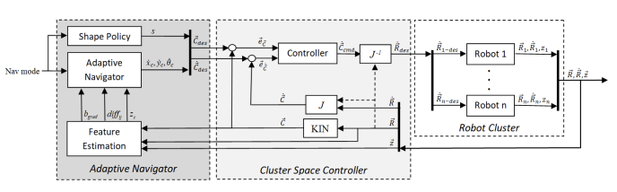
FIGURE 2: MULTILAYERED CONTROL ARCHITECTURE BLOCK DIAGRAM [2]
This architecture was selected because its modular layered approach allows for independent development and testing of different components of the overall architecture. This approach also maximizes system reusability, enabling systematic comparison of navigation strategies using standardized components in downstream layers. Additionally, the architecture enables the same control laws to be applied across different robot platforms and formations.
2.2 Robot Control Layer
The robot control layer is responsible for turning high level velocity commands into actuations on relevant hardware. The robots used for this testbed are Decabots, a fleet of omnidirectional rovers developed at Santa Clara University [15]. They are equipped with tcs34725 RGB sensors on their undercarriage, enabling them to sense the color patterns of the colored floor mat underneath and estimate the vector field being represented at that point. Each is powered by an Arduino and communicates over TCP/IP to a host computer that interprets the robots sensed value, uses the information to calculate and return robot velocity commands to each robot. Each robot has its own controller that translates these velocity commands into torques on its motors. Each robot has a maximum linear velocity of 0.3 m/s. No modifications to these robots from their original design were made for this study. A perspective view of the Decabot can be seen in figure 3. It has omnidirectional wheels, as well as small reflective spheres on its roof, which enable tracking with the motion capture cameras.
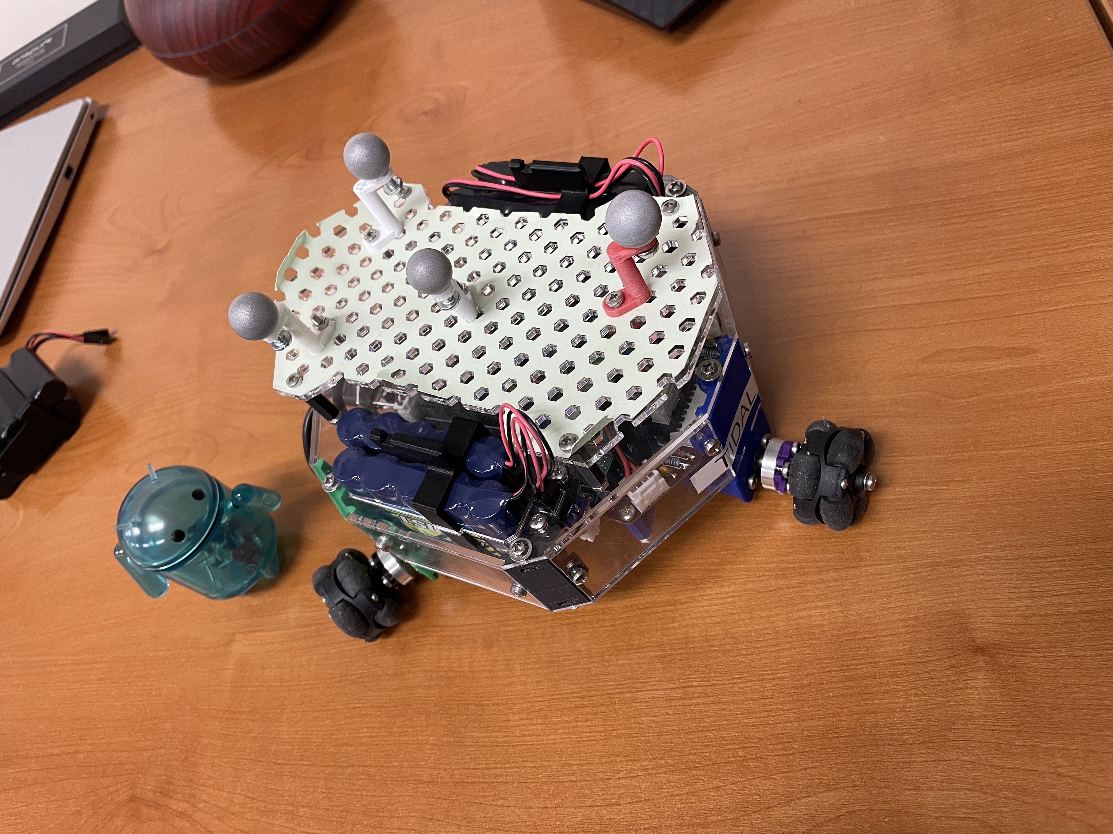
FIGURE 3: A DECABOT ROVER WITH OPTITRACK MOTION TRACKING BALLS ATTACHED
2.3 Cluster Space Controller Layer
To maintain a fixed formation while commanding all robots with velocity commands individually, a cluster space controller was used. Cluster Space control is a technique developed by Dr. Chris Kitts of Santa Clara University [20]. In this technique, all robot positions are described geometrically relative to a cluster frame via a set of kinematic equations. An example of a 3 robot cluster in a 2-dimensional plane can be seen in figure 3.
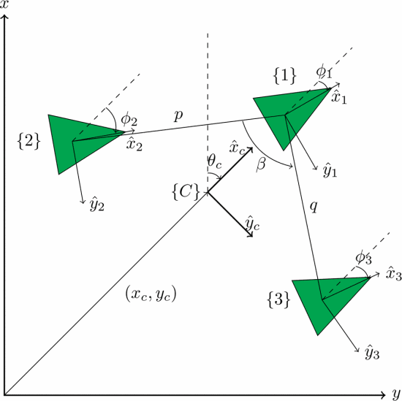
FIGURE 4: A 3-ROBOT CLUSTER WITH CLUSTER SPACE VARIABLES [2]
Cluster space control also provides a closed form method for converting between cluster level commands and robot level commands. This allows for the user or adaptive navigation layer to specify the behaviour commands for the entire cluster, and the individual robots are then commanded to react accordingly. This is done through a set of closed form equations. These conversions happen on a centralized computer, after the individual robots communicate their instantaneous position and sensed information. A full description of the Kinematics, Jacobian (J) and Inverse Jacobian ( $J^{-1}$) for the cluster shown in figure 3 can be found in [2].
$$\left[\begin{matrix}{\dot{x}}_{1} \\ {\dot{y}}_{1} \\ {\dot{θ}}_{1} \\ {\dot{x}}_{2} \\ {\dot{y}}_{2} \\ {\dot{θ}}_{2} \\ {\dot{x}}_{3} \\ {\dot{y}}_{3} \\ {\dot{θ}}_{3}\end{matrix}\right] \left[\begin{matrix} \\ \\ → {J }^{ } → \\ \\ \\ ← J^{-1} ← \\ \end{matrix}\right] \left[\begin{matrix}\dot{x_{c}} \\ \dot{y_{c}} \\ {\dot{θ}}_{c} \\ \dot{p} \\ \dot{q} \\ \dot{β} \\ \dot{ϕ_{1}} \\ \dot{ϕ_{2}} \\ \dot{ϕ_{3}}\end{matrix}\right]$$
FIGURE 5: RELATIONSHIP OF CLUSTER SPACE VELOCITIES AND ROBOT SPACE VELOCITIES
2.4 Adaptive Navigation Layer
The adaptive navigation layer contains the cluster shape policy, and the feature estimator, and the control law. This layer determines the desired actions of the entire cluster in cluster space variables according to the control law.
For this research, a 3-robot cluster with a constant shape policy as shown in figure 4 was used. The cluster values chosen to be constants with values, p=0.35m, q = 0.35m, and β= 1.05 rads. These values were chosen as they provided a tight grouping for the robots, and also ensured the shape was of an equilateral triangle. The ability to maintain this formation explicitly while maintaining full controllability and observability was the reason cluster control was chosen as the middle layer, instead of a swarm architecture, leader follower, or other alternative. The orientation of the cluster and of the individual robots was not specified. This was done to ensure all velocity commands were directly related to the control primitives, and not to maintaining orientation.
The feature estimator is responsible for processing data collected and transmitted by the Decabots into useful information for the control law. In this application, the feature estimator is converting data from the robots’ RGB sensors into useful information for navigation decisions. Details on the feature estimator works is discussed in section 3.3.
2.5 Multirobot Control Primitives for Vector Fields
Two different Adaptive Navigation Primitives were used as control laws to test the effectiveness of this new platform. Both primitives were previously identified and verified in simulation [2] and their limitations discussed. It is important to note that these primitives only rely on instantaneous information, and as such allow for purely reactive approach to adaptive navigation control.
The first primitive used in this study is the vector sum technique. In this technique, the vectors sensed by each robot are summed together. The direction of the resultant vector is then normalized and used to specify ${\dot{x}}_{c}$ and ${\dot{y}}_{c}$ for the cluster.
The second primitive used in this study is the Vector to Scalar technique. In this technique only the magnitude information from the vector readings is used, effectively converting the vector field navigation problem into a scalar field problem. This allows for scalar field gradient ascent primitives to be used. For example, in the max seeking primitive, differences in magnitude of the vector readings from the individual robots are used to determine the direction of steepest change. Equations 2 through 6 describe this max seeking primitive, showing how the x and y coordinates of each robot and the magnitude of their vector readings (z) are used to specify ${\dot{x}}_{c}$ and ${\dot{y}}_{c}$ for the cluster. A minimum seeking behaviour follows the same equations, except moving in the negative ${\dot{x}}_{c}$ and ${\dot{y}}_{c}$ directions.
$$\begin{aligned}{\vec{R}}_{12}=\left({x_{2}-x_{1} \atop \begin{aligned}y_{2}-y_{1} \\ z_{2}-z_{1}\end{aligned}}\right) \#\left(1\right)\end{aligned}$$
$$\begin{aligned}{\vec{R}}_{13}=\left({x_{3}-x_{1} \atop \begin{aligned}y_{3}-y_{1} \\ z_{3}-z_{1}\end{aligned}}\right) \#\left(2\right)\end{aligned}$$
$$\begin{aligned}\vec{N}={-\vec{R}}_{13}× {\vec{R}}_{12} \#\left(3\right)\end{aligned}$$
$$\begin{aligned}b_{grad}=ATAN2\left(N_{y} , N_{x}\right)+ \frac{π}{2} \#\left(4\right) \\ {\dot{x}}_{c}=cos⁡( b_{grad} )\#\left(5\right) \\ {\dot{y}}_{c}=cos⁡( b_{grad} )\#\left(6\right)\end{aligned}$$

- TEST BED DESIGN

3.1 Testbed Overview
This research used an existing testbed as a starting point [15]. It includes three omnidirectional mobile rovers (Decabots), 2.3 m² multicolored floor maps representing different vector fields, a motion capture system (OptiTrack) to verify the position of the robots relative to the floor mat with centimeter level accuracy. The Decabots and OptiTrack communicate to a central computer via WIFI. The central computer acts as the main controller, hosting the control architecture implemented in MATLAB/Simulink. The central computer processes the information received then communicates robot velocity commands back to each individual robot. Figure 1 shows the layout of all the equipment.
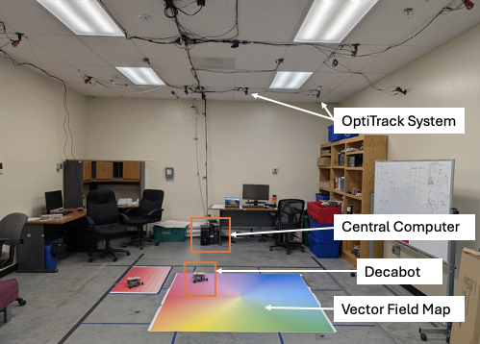
FIGURE 1: OVERVIEW OF TESTBED DEVELOPED FOR TESTING VECTOR FIELD ADAPTIVE NAVIGATION
3.2 Modelling Vector Fields in Colorspace
Previous attempts to use RGB colors to represent an orthogonal set of vectors showed limited success as only as small portion of the spectrum was usable when portions of high interference were eliminated [18]. To allow for more variance in colors, an HSV colorspace was used to model vector space. Hue, which is circular in nature, was a natural choice for representing the direction of the vector. Saturation, ranging from 0 to 1, was used to represent the possible range of magnitudes. Saturation was chosen for representing magnitudes as early tests found that the value channel was very sensitive to differences in ink levels from the printer, ambient lighting, and other effects such as shadows. Figure 6 shows a saturation vs hue plot, which represents all possible vector representations.
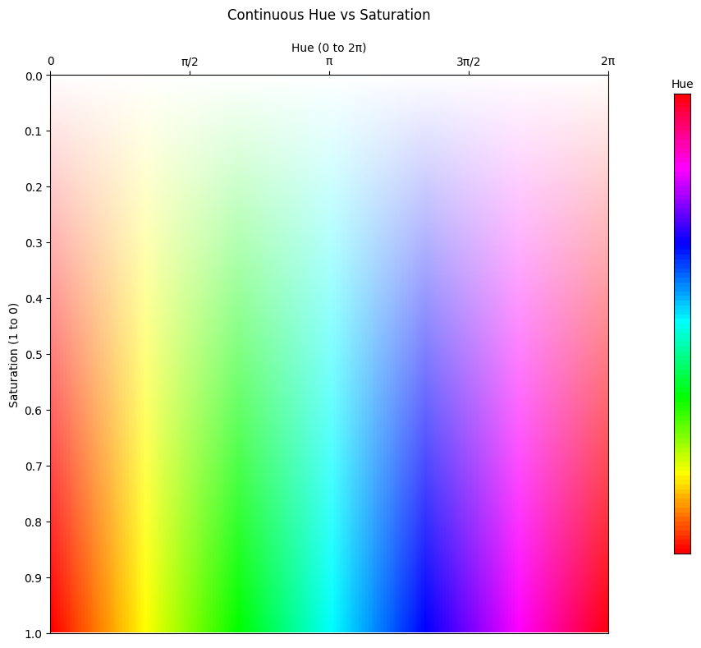
FIGURE 6: A PLOT OF SATURATION VS HUE TO REPRESENT VECTOR SPACES
This methodology was used to construct two vector fields for this experiment. The first vector field studied was that of a fixed vortex. It was modelled using equations 7 through 10 below:
$$\begin{aligned} r = {\left({\left(x - center_{x}\right)}^{2} + {\left(y - center_{y}\right)}^{2}\right)}^{\frac{1}{2}} \#\left(7\right) \\ θ = atan2(y - center_y, x - center_x) \#\left(8\right) \\ u = r * sin⁡(θ) \#\left(9\right) \\ v = -r * cos⁡(θ) \#\left(10\right)\end{aligned}$$
Once all the vectors have been created at every point in the plot, they were scaled to the range of 0.3 to 1. Values less than 0.2 were not used in training, and values less than 0.3 have problems with stiction. Figure 7 below shows the vector field resulting from equations 7 through 10 as a quiver plot overlayed on an HSV plot.
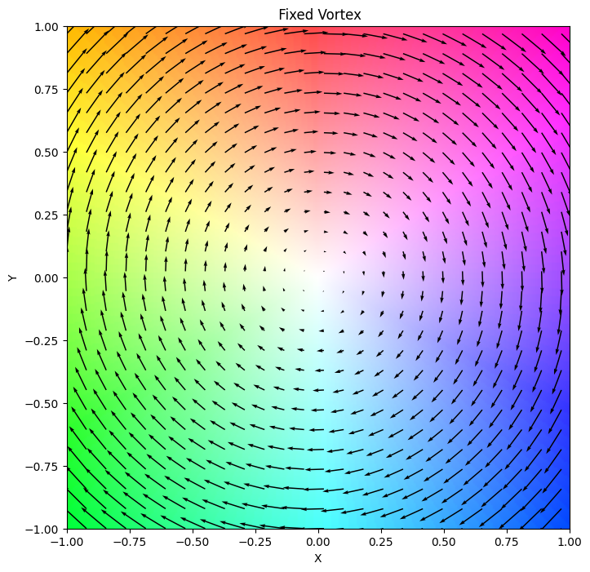
FIGURE 7: QUIVER PLOT AND HSV PLOT OF FIXED VORTEX CENTERED AT THE ORIGIN
The other vector field studied was that of a sinking vortex. The equations below describe how the vector field is modeled. A small value of $1e^{-6}$was added to denominator to avoid errors when attempting to divide by 0 when r=0. Once again, all vectors in the plot are scaled to the range of 0.3 to 1 after They are computed using equations 11-16 below. The r vector field resulting from these equations is shown in figure 8 as a quiver plot overlayed on an HSV plot.
$$\begin{aligned} r = {\left({\left(x - center_{x}\right)}^{2} + {\left(y - center_{y}\right)}^{2}\right)}^{\frac{1}{2}} \#\left(11\right) \\ θ = atan2(y - center_y, x - center_x) \#\left(12\right) \\ u = r * sin⁡(θ) \#\left(13\right) \\ v = -r * cos⁡(θ) \#\left(14\right) \\ u = u+\frac{{0.1*\left(x - center_{x}\right)}^{ }}{r^{2} +1e^{-6}} \#\left(15\right) \\ v = v+\frac{{0.1*\left(y - center_{y}\right)}^{ }}{r^{2} +1e^{-6}} \#\left(16\right)\end{aligned}$$

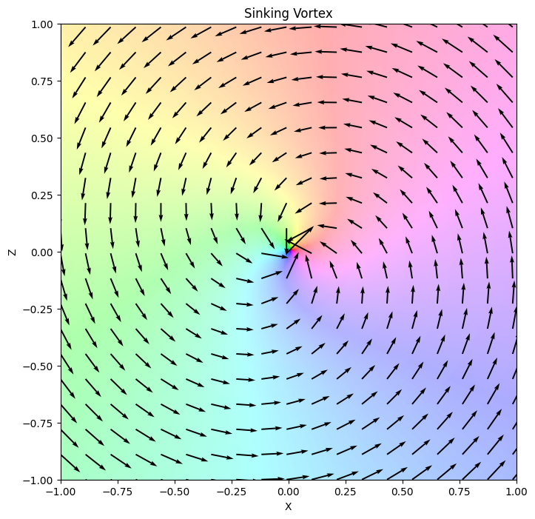
FIGURE 8: QUIVER PLOT AND HSV PLOT OF SINKING VORTEX CENTERED AT THE ORIGIN

3.3 Feature Estimation and Sensor Calibration
The RGB sensor data suffered from channel interference as noted in previous studies. The tcs34725 spec sheet confirms that blue, green, and red channels cannot be fully isolated. This effect persisted, even after conversion to an HSV colorspace. Traditional calibration methods did not significantly improve performance, and were prohibitive if the need to scale up occurred. These complications prompted an exploration of a supervised learning approach, discussed below.
A calibration pallet was created with varying hues (0-2π) and saturations with values spaced at 24 equal intervals in each dimension. Three robots were carefully positioned above each subplot, and the RGB and K measurements were recorded alongside the hue and saturation levels they were meant to detect (see figure 9).
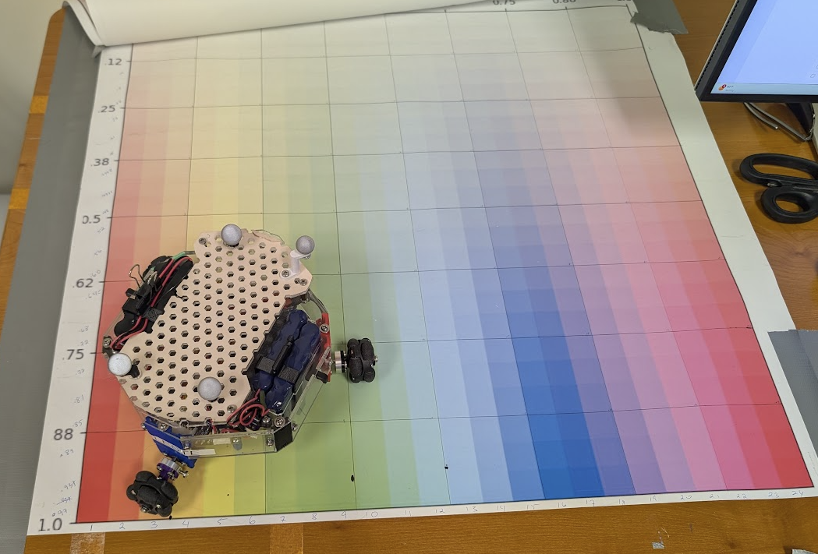
FIGURE 9: DECABOT COLLECTING TRAINING DATA FOR VECTOR ESTIMATION MODELS
The dataset created from collecting readings from 3 robots was combined, then augmented once or twice by introducing ±1% noise to RGB readings, ensuring robustness.
The collected RGBK values were normalized between 0 and 1, then converted to HSV values using standard MATLAB libraries, and the resulting values were appended to original data. This resulted in a 7 dimensional input space (R,G,B,K,H,S,V). Data points with saturation values less than 0.2 were removed from the data set as a measure to boost model performance. All inputs and target values were normalized to [-1,1] range prior training.
Two separate neural networks were created using MATLAB's Deep Learning Toolbox: one to predict Hue and the other to predict saturation. To address the circular nature of hue values, the hue target was decomposed into sine and cosine components, creating a two-target configuration. Saturation was handled with direct mapping.
To determine the appropriate size of the hidden layers, a random search approach was used, searching in the range 2,12 for layer 1, and 4,10 in layer two. The model patience, and number of augmentations were also randomized. The Levenberg-Marquardt optimizer and default learning rate well held constant.
For both networks, Tanh activation functions were used for non-linearity. The data was split into training (70%), validation (15%), and test (15%) sets.
After training, the models for hue and saturation were tested against 8 different validation sets. The first three datasets are on the original calibration data, inclusive of the validation and test subsets. A fourth robot is used to sample the calibration pallet, creating the fourth test dataset. Each of the robots are then used to sample a separate test pallet with saturation levels ranging from 0.25 to 0.95 in 0.1 intervals, and hue divided into 10 equal intervals from 0 to 2π, creating another 4 datasets for validation. Performance metrics on each validation set were recorded, and they best scores after random search was selected for the remainder of the study.
3.4 Robot Velocity from Saturation Testing
To validate the relationship between detected vector magnitude and robot velocity, lanes of a single hue at different saturation levels were printed (figure 10). Each robot was placed on each of the different saturation lanes and commanded to follow the direction based on hue, and to use the magnitude indicated by saturation to scale its velocity.
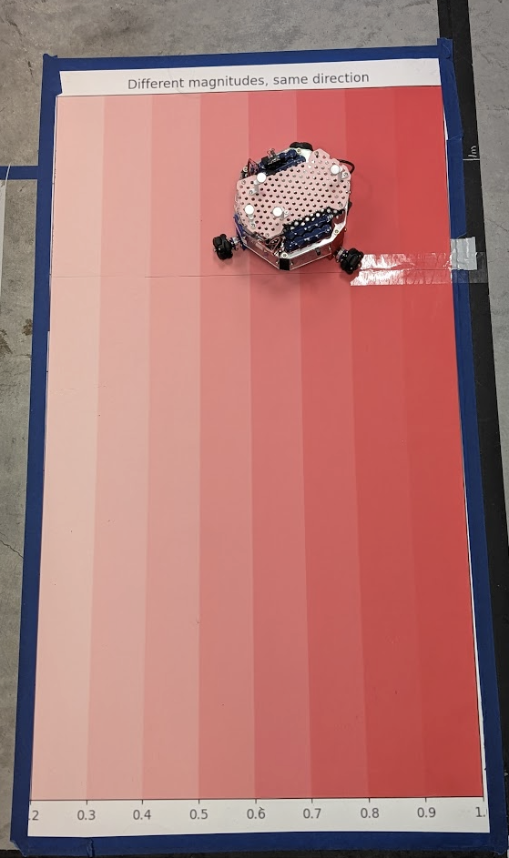
FIGURE 10: LANES OF HUE=0 FOR TESTING DECABOT VECOLITIES WITH DIFFERENT SATURATION LEVELS
Each robot’s position was tracked over a 3 second period as it followed each lane. The average velocity for each saturation run was computed and plotted (figure 11). Across all robots, the velocities scaled linearly with saturation at values above 0.3. Saturation values below 0.3 did not produce velocity commands strong enough to overcome stiction of the robots. The robots achieved a max velocity of 0.3 m/s. This consistency between saturation and robot velocity across robots is key for interpreting vector primitive performance.
FIGURE 11: AVERAGE VELOCITY OF ROBOTS WHEN SENSING DIFFERENT SATURATION LEVELS
- RESULTS AND DISCUSSION

4.1 Sensor Calibration Results
Table 1 below shows the of hue and saturation predictions across 8 datasets mentioned in section 3.3. In all cases, the hue network had a circular R² of 0.96 or greater and a circular RMSE of 0.05 or smaller. Likewise, the saturation model scored greater than an R² of 0.93 and an RMSE of 0.079 or smaller on all validation sets. This level of accuracy is sufficient for this testbed are within the noise floor of the sensors themselves.
TABLE 1: PERFORMANCE OF CROSS ROBOT MODEL ON 8 VALIDATION SETS
 | Hue Network |  | Sat Network
Model | R² | RMSE | R² | RMSE
R1 Calibration Plot | 0.996 | 0.017 | 0.950 | 0.054
R1 Verification Plot | 0.969 | 0.050 | 0.95 | 0.064
R2 Calibration Plot | 0.998 | 0.013 | 0.935 | 0.061
R2 Verification Plot | 0.967 | 0.052 | 0.943 | 0.069
R3 Calibration Plot | 0.998 | 0.014 | 0.948 | 0.055
R3 Verification Plot | 0.991 | 0.027 | 0.953 | 0.062
R4 Calibration Plot | 0.993 | 0.024 | 0.908 | 0.073
R4 Verification Plot | 0.964 | 0.054 | 0.925 | 0.079

The models ability to generalized to unseen data is best demonstrated when it used to test readings from a robot that wasn’t used for training. In these plots, (R4 rows on the table), the trained network predicted hue with a circular R² of 0.993 and a circular RMSE of 0.024. The magnitude model had an R² of 0.908 and an RMSE of 0.073. Figure 10 visualizes the prediction results on the data collected from the calibration plot using the fourth robot. In both graphs, all predictions are very close to the perfect prediction line.
FIGURE 10: PREDICTED HUE AND SATURATION GIVEN DATA COLLECTED FROM ROBOT USING MODEL TRAINED ON THREE OTHER ROBOTS
The performance of the generalized model reported in table 1 is on par with that of individually tuned models, suggesting that the cross-trained method could be used on additional robots with the same sensor. Table 2 shows scores of each robot when they are tuned individually. All models trained individually on robots had an R² accuracy greater than 0.99, for hue and all having R² values over 0.95 on saturation when testing the verification plot. This increased accuracy is minimal, and took several hours to perform.
The generalized model immediately helps with scaling the system to greater number of robots. Instead of performing a full calibration on each new robot, the robot can be loaded with the cross-trained interpretation models, and the smaller verification plot can be sampled and used for acceptance testing.
TABLE 2: MODEL INFERENCE PERFORMANCE ON INDIVIDUALLY TUNED SENSORS
Robot | Channel | Calibration Plot |  | Testing Plot
 |  | R² | RMSE | R² | RMSE
1 | Hue | 0.999 | 0.009 | 0.995 | 0.020
1 | Sat | 0.972 | 0.040 | 0.963 | 0.055
2 | Hue | 0.996 | 0.018 | 0.991 | 0.027
2 | Sat | 0.968 | 0.043 | 0.952 | 0.063
3 | Hue | 0.999 | 0.007 | 0.997 | 0.015
3 | Sat | 0.980 | 0.034 | 0.976 | 0.044

4.2 Control Primitive Results on Test Bed
The success of sensor calibration enabled testing of control primitives in different environments using the test bed.
The first set of test runs performed was using a 3 robot cluster to navigate around the center of a fixed vortex using the vector sum primitive. Figure 13 shows the average path travelled over 10 runs, and the shaded region shows 1 standard deviation along this path. This path is very consistent between runs, and the outward drift rate appears stable at all angles. This is expected as the robot only moves in is perceived direction, and the discrete time increments mean it is always moving tangent to the circle. More work needs to be done to analyze this outward drift. This behavior could possibly be mitigated with a more advanced control primitive.
FIGURE 13: AVERAGE PATH OF ROBOTS TRAVELLED IN FIXED VORTEX USING THE VECTOR SUM PRIMITIVE
The second set of test runs were performed on the sinking vortex environment using the vector sum technique. Figure 14 shows the robots following a smooth path as they spiral inwards towards the center as predicted in simulation. The solid lines show the average run, and the blurred area shows 1 standard deviation. The smoothness can be attributed to very high R² value with interpreting hue as well as to the stability of the center of this vortex field.
FIGURE 14: AVERAGE PATH OF ROBOTS TRAVELLED IN SINKING VORTEX WITH VECTOR SUM PRIMITIVE
Figure 15 shows the distance of the cluster center relative to the origin with time. In these tests, the cluster settles around 0.1m away from the center. Looking at image 14, the desired location falls within the boundaries of the triangle that connects the 3 robots in the cluster. This suggests that smaller cluster space variable values would lead to a more accurate prediction.
FIGURE 15: AVERAGE ERROR OF CLUSTER POSITION RELATIVE TO THE CENTER OF SINKING VORTEX
For the third set of test run, the vector-to-scalar min seeking primitive was used to find the center of the fixed vortex floor map. The robots are expected to follow a straight line to the center as seen in figure 16. The trajectory of the robots is very consistent across runs. The trajectory isn’t a perfectly straight line, as there may be noise in the printing, small fluctuations in robot behavior, and some variance in the way that saturations affect estimates of magnitudes.
FIGURE 16: AVERAGE PATH OF ROBOTS TRAVELLED IN FIXED VORTEX VECTOR TO SCALAR PRIMITIVE
In these test runs, the cluster settles within 0.2m away from the center. This suggests that the center falls within the circle that circumscribes the triangle formed by the three robots. Smaller cluster space variable values could lead to a resting point closer to true center. Figure 17 shows the distance of the cluster center moving steadily to its desired location, and settling a small distance away and remaining within a small area once it arrive there.
FIGURE 17: AVERAGE ERROR OF CLUSTER POSITION RELATIVE TO THE CENTER OF SINKING VORTEX
For a fourth set of tests, the Vector to Scalar min seeking primitive in a fixed vortex trial runs were repeated, but with different randomized starting positions in the colormap. Figure 18 shows target seeking performance with a steady state error close to error in the trial runs that all had the same starting location. This could be happening as the velocity command is from the gradient, and not from the saturation itself, resulting in velocity commands that are not sufficient to overcome stiction.
FIGURE 18: AVERAGE ERROR OF CLUSTER POSITION RELATIVE TO THE CENTER OF SINKING VORTEX WITH RANDOMIZED STARTING POSITIONS

4.3 Cluster Space Controller Results
Table 3 shows the average performance of the cluster controller in each environment with different control primitives. The table shows average cluster values are very close to the desired values p=0.35 m, q = 0.35m, and β= 1.05 rads.
TABLE 3: FORMATION CONTROL PERFORMANCE STATISTICS OF ROBOT CLUSTER TRIAL RUNS WITH SETPOINTS OF P = Q = 0.35m AND β = 1.05rads
 | Fixed Vortex |  |  |  | Sinking Vortex
Var | Vector-Sum |  | Vector-2-scalar |  | Vector-Sum
 | Average | Std dev. | Average | Std dev. | Average | Std dev.
P | 0.36 m | 0.028 | 0.35m | 0.015 | 0.35 m | 0.019
q | 0.36 m | 0.032 | 0.36m | 0.009 | 0.35 m | 0.015
β | 1.03 rads | 0.122 | 1.02 rads | 0.045 | 1.02 rads | 0.056

These results show the ability to hold formation within 1cm of the desired values. This is in line with the resolution limits of the OptiTrack system, indicating that the cluster space controller is working satisfactorily.
- SYSTEM LIMITATIONS

This testbed demonstrates a significant improvement over previous testbeds, yet some limitations persist. The system is fundamentally constrained to two-dimensional vector fields, and a method for extending to 3 dimensions using HSV color space is not possible due to extreme sensitivity in the value component. Any extension to 3 dimensions would require using additional sensors to interpret some other signal and combine into a vector.
The testbed area is also limited to a maximum of a 3m by 6m work area, and a minimum operational area of 1m x 1m to allow robots room to operate without collision.
The Decabots themselves are limited by their battery life to about an hour run time. They have a maximum velocity of 0.3 m/s and a minimum velocity of 0.05 m/s to overcome stiction.
Additionally, the Decabots wheels degrade both the paper and printed colors on the colormaps, necessitating replacement of the colormaps after a few dozen runs, which is quite costly.
- FUTURE WORK
Further trials are being performed on the test bed to better quantify the system's capabilities. This includes statistical analysis on position accuracy and formation maintenance. Work is also being done to create digital twins of the Decabots, by using the systems ability to capture the velocity and acceleration dynamics of the rovers, enhancing the sim2Real experience [22].
The system's ability to accurately reproduce both direction and magnitude of vectors enables the study and testing of real-world dynamics of multirobot systems. Studying the dynamics of a cluster as a whole has not been studied in depth, and this test bed allows for development of this area of research.
There are plans to use this testbed can be used to validate simulations of new control primitives that are currently in development to find features of interest in vector fields, such as navigation to stagnation points and maintaining orbit at a fixed distance. The approaches being developed usea more advanced mathematical techniques, including Jacobian-based analysis with eigenvalue decomposition, and calculations of curl and divergence to understand the topological features of the vector fields. This could extend to working with singularities in vector fields, singularities with certain robot formations, and incorporating complex trajectories such as homoclinic orbits [23].
The platform could also serve as an experimental environment for multirobot reinforcement learning algorithms, for testing artificial vector field control methodologies and for exploring swarm-based controllers, especially with the cross-robot model tuning being validated allowing for ease when scaling up the number of robots [24].
- CONCLUSION

This project was successful in overcoming the limitations of previous vector field testbeds. It overcame the channel coupling issue by using an HSV color space and by using a supervised learning approach for sensor tuning. This testbed can accurately represent direction with an R² accuracy of over 0.96 using hue and represent magnitude with an R² accuracy of 0.91 using saturation. It demonstrated multirobot capabilities and had motion capture mechanisms to verify the performance in a quantifiable manner and was used for experimental verification of results from previous vector field studies that were only performed in simulation. It also opens the door to testing new control strategies for other vector field environments in a real-world testbed.
ACKNOWLEDGEMENTS
Special thanks to Scot Tomer for taking time to review the original Decabots Test Bed, and to Jiayi Wang who helped facilitate the large-format printing in house. Special thanks also goes out to Michael Waight for our discussion on HSV Space and my wife, Sara Alvarez, as proof reader.
REFERENCES
[1] C. A. Kitts and M. Egerstedt, “Design, control, and applications of real world multirobot systems [from the Guest Editors],” IEEE Robot. Autom. Mag., vol. 15, no. 1, p. 8, Mar. 2008.
[2] Cooper, Ryan, et al. "Initial Study of Multirobot Adaptive Navigation for Exploring Environmental Vector Fields." 2019 IEEE Aerospace Conference. IEEE, 2019.
[3] Gradient-Based Cluster Space Navigation for Autonomous Surface Vessels Thomas Adamek, Member, IEEE, Christopher A. Kitts, Senior Member, IEEE, and Ignacio Mas, Member, IEEE
[4] S. T. Hart and C. A. Kitts, "Unifying Control Architecture for Reactive Particle Swarms," in IEEE/ASME Transactions on Mechatronics, vol. 28, no. 2, pp. 873-883, April 2023, doi: 10.1109/TMECH.2022.3211155.
[5] C. A. Kitts, R. T. McDonald, and M. A. Neumann, “Adaptive navigation control primitives for multirobot clusters: Extrema finding, contour following, ridge/trench following, and saddle point station keeping,” IEEE Access, vol. 6, pp. 17 625–17 642, 2018.
[6] McDonald, Robert T., et al. "Navigation of scalar fronts with multirobot clusters in simulation and experiment." IEEE Systems Journal 14.3 (2020): 3755-3766.
[7] Wang, J., Guo, Y., Fahad, M., and Bingham, B., 2019, “Dynamic Plume Tracking by Cooperative Robots,” IEEE/ASME Transactions on Mechatronics, early access.
[8] Hu, Bin-Bin, et al. "Spontaneous-Ordering Platoon Control for Multirobot Path Navigation Using Guiding Vector Fields." IEEE Transactions on Robotics (2023).
[9] Nelson, Derek R., et al. "Vector field path following for miniature air vehicles." IEEE Transactions on Robotics 23.3 (2007): 519-529.
[10] Liddy, Tommie, et al. "Obstacle avoidance using complex vector fields." Proc. of the 2008 Australasian Conference on Robotics and Automation, Canberra, Australia. 2008. – Single Robot with artificial vector field.
[11] Matveev, Alexey, et al. "Gradient-free tracking of unsteady environmental level sets in dynamic environments by a nonholonomic robot." IFAC-PapersOnLine 53.2 (2020): 9256-9261.
[12] Matveev, Alexey, et al. "Non-Gradient Based Tracking of Environmental Field Isolines in a Changing Medium by Dubins-Vehicle Type Robots." IEEE Transactions on Automatic Control (2023).
[13] Michael, Nathan, Jonathan Fink, and Vijay Kumar. "Experimental testbed for large multirobot teams." IEEE robotics & automation magazine 15.1 (2008): 53-61.
[14] Rajabhandharaks, Danop, et al. "Indoor Testbed for Vector Field Multirobot Adaptive Navigation: Feasibility Study." International Design Engineering Technical Conferences and Computers and Information in Engineering Conference. Vol. 59292. American Society of Mechanical Engineers, 2019.
[15] S. Tomer et al., "A low-cost indoor testbed for multirobot adaptive navigation research," 2018 IEEE Aerospace Conference, Big Sky, MT, USA, 2018, pp. 1-12, doi: 10.1109/AERO.2018.8396787.
[16] I. Mas, S. Li, J. Acain, and C. A. Kitts, “Entrapment/escorting and patrolling missions in multi-robot cluster space control,” in Proc. IEEE/RSJ Int. Conf. Intell. Robots Syst., St. Louis, MO, USA, Oct. 2009, pp. 5855– 5861.
[17] M. Woolsey, C. A. Kitts and M. A. Neumann, "Gradient-based Adaptive Navigation of Multiple Diving Autonomous Surface Vehicles," OCEANS 2022, Hampton Roads, Hampton Roads, VA, USA, 2022, pp. 1-8, doi: 10.1109/OCEANS47191.2022.9977006.
[18] Lee, Robert K., et al. "3-d adaptive navigation: Multirobot formation control for seeking and tracking of a moving source." 2020 IEEE Aerospace Conference. IEEE, 2020.
[19] R. K. Lee, C. A. Kitts, M. A. Neumann and R. T. Mcdonald, "Multiple UAV Adaptive Navigation for Three-Dimensional Scalar Fields," in IEEE Access, vol. 9, pp. 122626-122654, 2021,doi: 10.1109/ACCESS.2021.3107854.
[20] C. A. Kitts and I. Mas, "Cluster Space Specification and Control of Mobile Multirobot Systems," in IEEE/ASME Transactions on Mechatronics, vol. 14, no. 2, pp. 207-218, April 2009, doi: 10.1109/TMECH.2009.2013943.
[21] Jammalamadaka, S. Rao, and Ambar Sengupta. Topics in circular statistics. Vol. 5. world scientific, 2001.
[22] Mañas-Álvarez, Francisco-José, et al. "Robotic park: Multi-agent platform for teaching control and robotics." IEEE Access 11 (2023): 34899-34911.
[23] Yao, Weijia, et al. "Singularity-free guiding vector field for robot navigation." IEEE Transactions on Robotics 37.4 (2021): 1206-1221.
[24] Hart, Shae T., Jake Kamenetsky, and Christopher A. Kitts. "Dynamic Elliptical Shaping Control for Swarm Robots." IEEE Access 11 (2023): 17454-17470.

